Ac Millivoltmeter

The 1808 Ac Millivoltmeter is a wide-band, average-reading instrument calibrated to read rms sine-wave and dBm values ranging from 150 micro V to 150-V full scale in six discrete 20-dB ranges (or to 1500-V full scale with an external probe and adaptor). The instrument will accurately measure sine-waves within a bandwidth ranging from 10 Hz to 10 MHz on the 15-mV through 150-V ranges, and to 4 MHz on the 1.5-mV range. In addition, the unit possesses a wide 20-dB dynamic range per range, which makes it ideal for such applications as amplifier-response measurements, attenuator -calibration, and high-resolution ac measurements.

RF Voltage Measurement

Measurement of radio frequency voltage is difficult especially when the magnitude is very small and the frequency is very high. Naturally when small magnitudes are to be measured, we certainly need amplification of the signal, that too at the signal frequency.

Radio frequency signal amplification is complicated and requires special devices, and has several restrictions on the component size, orientation, and shielding is very important. In spite of all the precautions taken the bandwidth restriction again poses a problem. Stability of the gain of the amplifier is yet another problem. For accurate measurement care is to be taken in the design of the instrument considering all the above constrains.

R.F. millivolt meter can be either of the amplifier rectifier type or the rectifier amplifier type. thee amplifier rectifier type again can be the average reading type, peak reading type or true R.M.S. reading type.
In amplifier rectifier type of instrument initially the radio frequency signal will be amplified in a wide band amplifier. The output of the amplifier will be used in a detector to obtain an indication in the indicating instrument, which reads the value of the input voltage by proper calibration of the instrument.

In the rectifier amplifier type of radio frequency voltage measurement, the input signal will initially be rectified. The rectified D.C. will be amplified in a D.C. amplifier. The output of the D.C. amplifier will be connected to an indicating instrument which will be calibrated in terms of the input signal.

Amplifier Rectifier Type A.C. Millivoltmeter

In this type of instrument the input signal will first be amplified in a wide band amplifier. The output of the wide band amplifier will be used in a rectifier to get a D.C. output which will be indicated in an indicating instrument.

(a) Classification

Depending on the type of rectifier arrangement used in the circuit we have three types of A.C. millivoltmeters as listed below:
(i) The average reading type
(ii) The peak reading type
(iii) The true R.M.S. reading type

(i) The Average Reading Type

In this type the dial calibration will be made multiplying the average output of the rectifier by the form factor 1.11, for the sinusoidal waves. For square wave inputs the reading will be more than the true R.M.S. value by 11%. For triangular wave inputs the reading will be less than the true R.M.S. value by 4%.

(ii) The Peak Reading Type

In this type the detectors response will be quick for increasing amplitudes of the input signals. The response will be slow for the decreasing amplitudes. As it is the peak detector that is employed, it "holds" the peak indefinitely. Practically a suitable decay will be obtained by properly choosing the time constant selecting the value of capacitor and load resistor in the peak detector.

(iii) The True R.M.S. Reading Type

The true R.M. S. type indicates the R.M.S. value of the input signal for any type of waveform. It is for this purpose the amplifier and the detector must be confined to their linear region of operation. The true R.M.S. indication will be specified for a given maximum value of "crust factor", which is less than 5. The crest factor will be more than 5 in special cases like the pulse train that have a low duty ratio. Therefore the true R.M.S. meter is generally specified for the crest factor value of 5, for an input signal having an R.M.S. value that equals the full scale deflection.

Description of the Block Diagram

The block diagram of the a.c. millivoltmeter is shown in Figure. From the block diagram it can be seen that the input signal to be measured will reach the wide band amplifier through a calibrated attenuator.

The output of the wide band amplifier is supplied to the linearized detector. The output of the detector is given to the indicating instrument. Two more detectors which are optional have been shown in the block diagram to indicate the three types of arrangements that can be hand in this type of instrument. The two other blocks of detectors are shown to have been connected in dotted lines. The choice of the detector is optional. Further the output of the wide band amplifier can be terminated over a socket as an optional output terminal, as is shown in the block diagram.

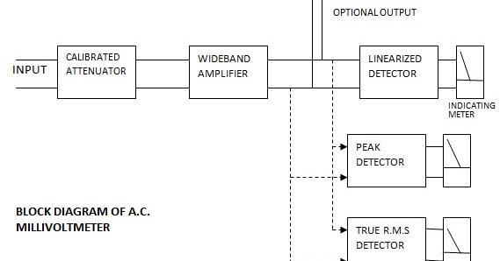

Applications

Noise analysis
Turbulance studies
R.M.S. power measurement in power systems using thyristor.

Limitations

The rectifier amplifier type of A.C. millivoltmeters performance is limited by the bandwidth of the amplifier. They can be used up to around 5 MHz, beyond which their accuracy will be poor.

R.F. MILLI VOLTMETER OF THE RECTIFIER AMPLIFIER TYPE

As the amplifier rectifier type of millivoltmeters performance is limited by the band width of the amplifier, an alternative is thought over that gave raise to the rectifier amplifier type A.C. millivoltmeter.

In this instrument initially the input signal will be rectified. The rectified D.C. will be amplified. In order to avoid the loss of signal due to the connecting cable, the rectifier element is incorporated in the probe itself.

Selection of Diode and Amplifier

The diodes that are used with conventional type of alternating current meters cannot be used for rectification of the high frequency signals of the order of gigahertz region. The reason is their capacitance, and reverse recovery time.

For use at very high frequency rectification, Schottky barrier or point contact diodes are used When diodes are used at low forward biased voltages the rectified output will not equal the peak of the input. This results in the fact that for lower amplitudes of signal voltages, the rectified output will further be low.

Block Diagram of Rectifier Amplifier Type of AC Millivoltmeter

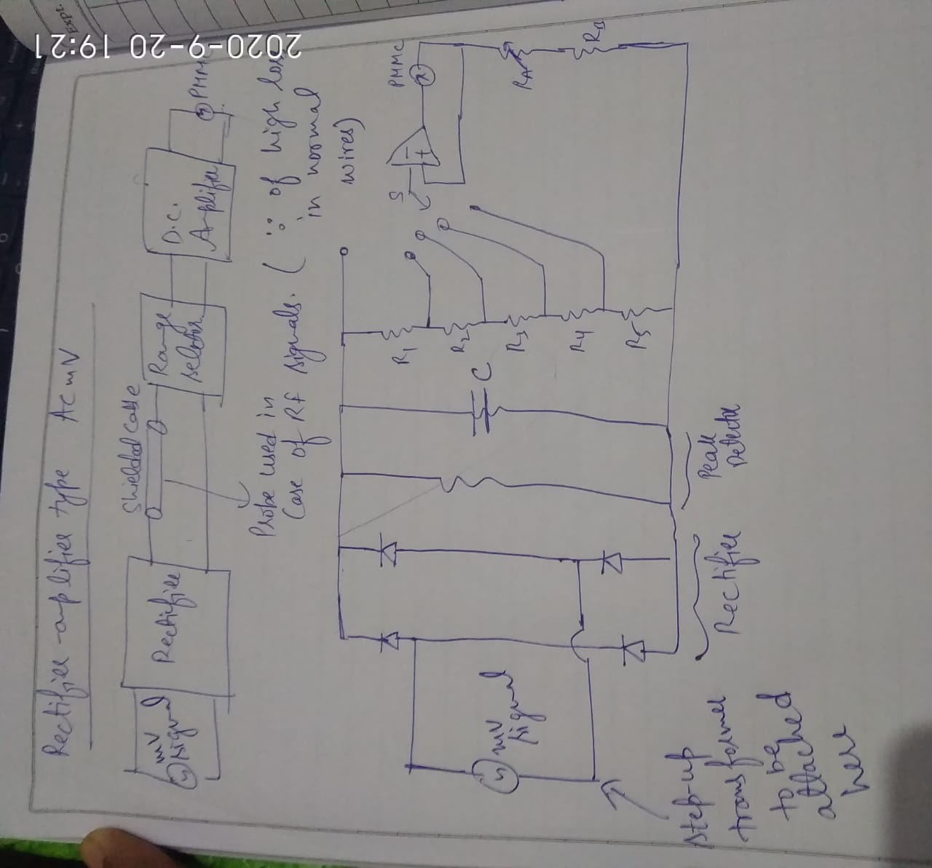Applications of R.F. millivoltmeter
This type of R.F. millivoltmeter is useful at very high frequencies.
It can be used for R.F. power measurement at frequencies of the order of gigahertz.

SPECIFICATIONS OF A.C. MILLIVOLTMETER

Voltage Range : 1.5 mV to 500 V full scale in 12 ranges in 1.5 and 5 sequence.

dB range : — 60 dB to + 60 dB in 12 decade ranges with 1 mW as '0' dB reference dissipated in a resistance of 600 ohm.

Frequency Range : 1 Hz to 5 MHz

Accuracy : ± 1% of reading, ± 1% of full scale reading

Input impedance : 5 MΩ

Predeflection : Less than 100 μV

Power requirement : 230 V, 50 Hz

